**PRIMARY Gymnastics Course**

This one day Primary Gymnastics course aims to develop attendees’ confidence and ability to plan and deliver safe and effective Gymnastics lessons.

This will be achieved through the sharing of planning tools, practical exploration of a Gymnastics unit of work, covering step by step progressions for forward roll, backward roll, headstand, handstand and cartwheel. Health and safety considerations will be addresses including those associated with the safe handling, layout and use of a range of apparatus. Attendees will also have the opportunity to work together to apply their learning through a live planningactivity.

**Aimed at:** Teacher’s & TA’s

**When** Wednesday 2nd October 2024 (9.20am-3.20pm)

**Where**: Comberton Village College

**Cost*:** £85 (***\*1 free place for CPD bolt on schools )***

**To book your place please visit the courses page on our website** [**www.scssp.co.uk**](http://www.scssp.co.uk) **or contact Vicky on**

[**sspadmin@combertonvc.org**](mailto:sspadmin@combertonvc.org) **/ 01223 262503 (11045)**

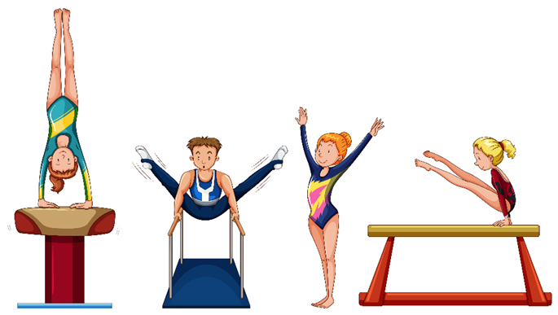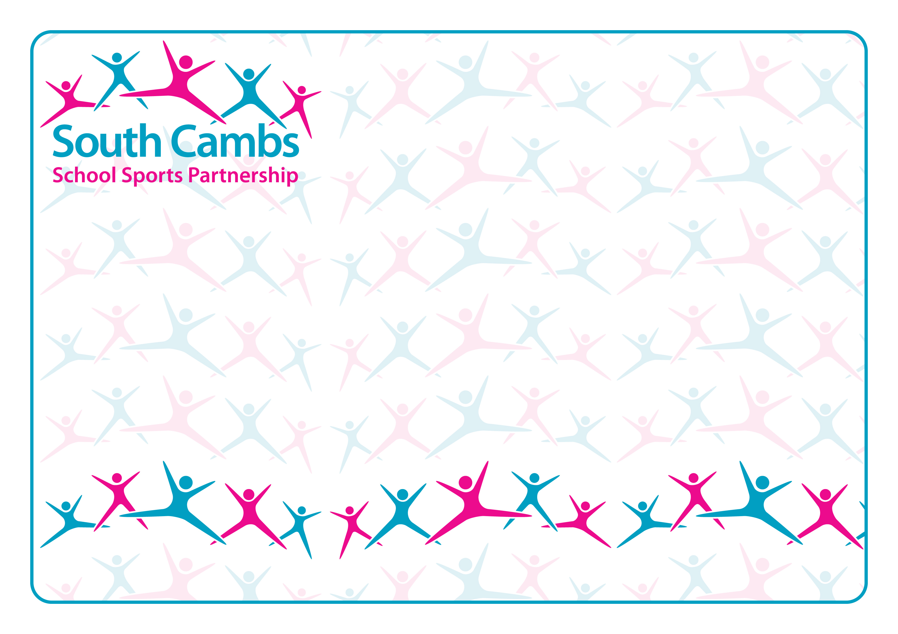

**Giving every young person a sporting chance**