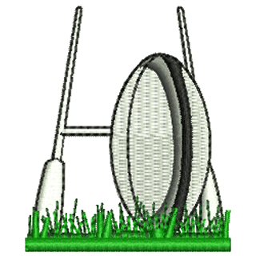

**RUGBY CLUB DETAILS**

|  |  |
| --- | --- |
| **Club Name** | **Website** |
| Biggleswade RUFC | www.biggleswaderufc.rfu.club |
| Cambridge RUFC | www.cambridgerugby.co.uk |
| Ely Tigers RFC | www.elytigersrugbyclub.com |
| Haverhill & District RFC | www.haverhillanddistrictrfc.rfu.club |
| Hitchin Rugby Club | www.hitchinrugby.com |
| Huntingdon & District Rugby | www.huntingdondistrictrugby.rfu.club |
| Newmarket RFC | www.newmarketrufc.com |
| Royston Rugby Club | www.roystonrugbyclub.co.uk |
| Saffron Walden RFC | www.saffronwladenrfc_new.rfu.club |
| Shelford RFC | www.shelfordrugby.co.uk |
| Stevenage Town RFC | www.stevenagerugby.rfu.club |
| St Ives RFC | www.pitchero.com/clubs/stivesrugbyfootballclub |
| St Neots Rugby Club | www.stneotsrugbyclub.com |
| Wendens Ambo Mini RFC | www.wendenrugby.com |

For further information you may wish to visit the RFU website: [www.englandrubgy.com](http://www.englandrubgy.com)

**Please note:** We are not endorsing or quality assuring any of the above clubs,simply providing contact information.The information provided is as accurate as possible

Please visit our website [www.scssp.co.uk](http://www.scssp.co.uk) for our latest news, courses and events.