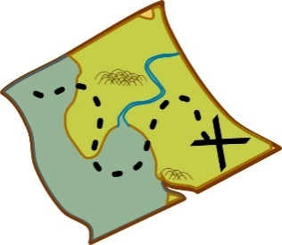

ORIENTEERING

Below is some information for Orienteering type activities in the local area. For further Orienteering specific information please visit the British Orienteering website: <https://www.britishorienteering.org.uk/> or<https://www.britishorienteering.org.uk/pocs>

**Orienteering clubs and local recreational courses**

* West Anglian Orienteering Club – [waoc.org.uk/](http://www.waoc.org.uk/)
* Links to all local permanent courses linked to West Anglian Orienteering Club can be found on our website, these can be used at any time just download the map for the area you would like to visit, for example Milton country Park, Hinchingbrook Country Park or Ferry Meadows Country Park
* Suffolk Orienteering Club - [suffoc.co.uk/](http://www.suffoc.co.uk/)
* Links to all local permanent course linked to Suffolk Orienteering Club can be found on our website.

Please use the link on our website for an explanation on how to download and use the maps using **MapRun**

**Other**

* Cambridge Treasure Hunt (various routes available) - £9.99 a map from - <https://www.treasuretrails.co.uk/trails-search/Cambridge,Cambridgeshire,England>

**Please note:** We are not endorsing or quality assuring any of the above clubs or activities,simply providing contact information.The information provided is as accurate as possible

Please visit our website [www.scssp.co.uk](http://www.scssp.co.uk) for our latest news, courses and events.