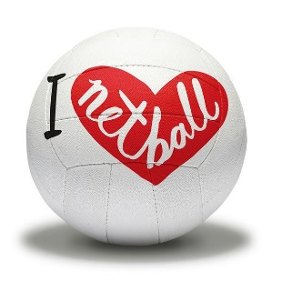
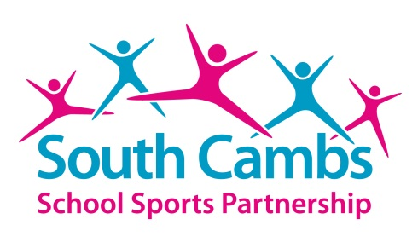
NETBALL CLUB DETAILS

For further information about Netball in the East Region you may wish to visit the
Netball East Website: www.netballeast.org.uk

Club Name | Website/email
Cambourne Netball Club | cambournejuniornetball@outlook.com
Cherries Netball Club | Floria_marie@yahoo.co.uk
City of Ely Netball Club (Years 7-11) | www.cityofelynetball.co.uk/juniornetball@hotmail.com
CoJags Junior Netball Club | www.cottenhamjaguarsnetballclub.com / rhettbayliss@aol.com or Sallyvail01@gmail.com
Comberton Netball Club | www.comberton-netball.co.uk / laurenhall5@hotmail.com
Haddenham Thistles Juniors | Mel.woor@hotmail.co.uk/chloe.woor1997@hotmail.com
Histon Howlers | https://sites.google.com/view/histonhowlers/home / Histon.howlers@gmail.com
Icons Junior Netball Club (Years 7-11) | Michellemoore27@googlemail.com/iconsnetball@gmail.com
Linton NC (Years 7-11) | lintonjuniornetballclub@gmail.com
Mission Impossible 7 | judesallis@gmail.com
Royston Junior Netball Club (Years 7-11) | roystonjuiornetball@gmail.com
SWAN Netball Club | www.swannetball.co.uk/julia455@btinternet.com or info@swannetball.co.uk
Warboys Witches | warboyswitches@outlook.com
Whittlesey Warriors | Melchamberlain021@gmail.com / lriley@sky.com

