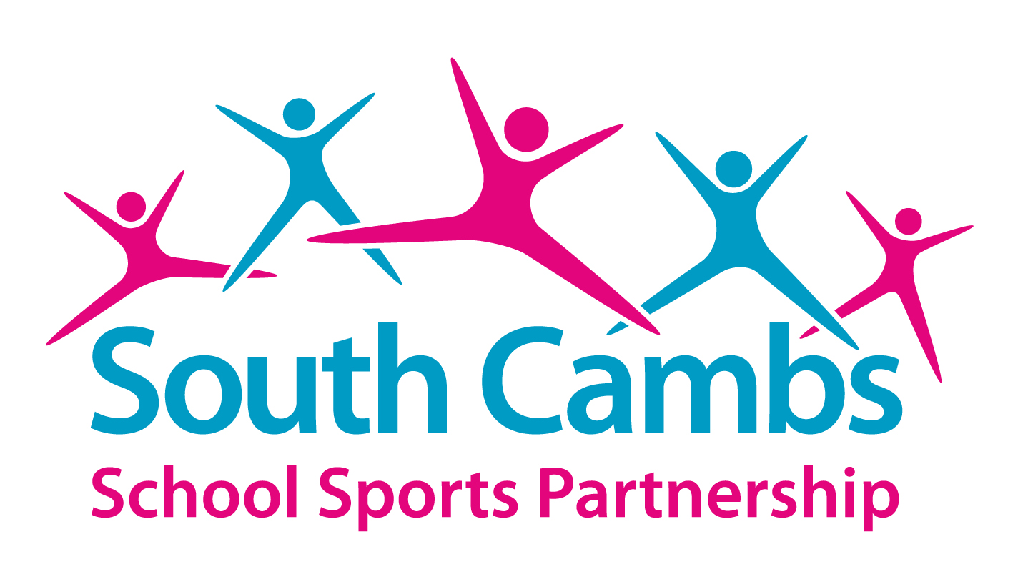
Comberton Village College, West Street,
Comberton, Cambridge CB23 7DU
(01223) 265470 ext 225

sspadmin@comberton.cambs.sch.uk
www.scssp.co.uk

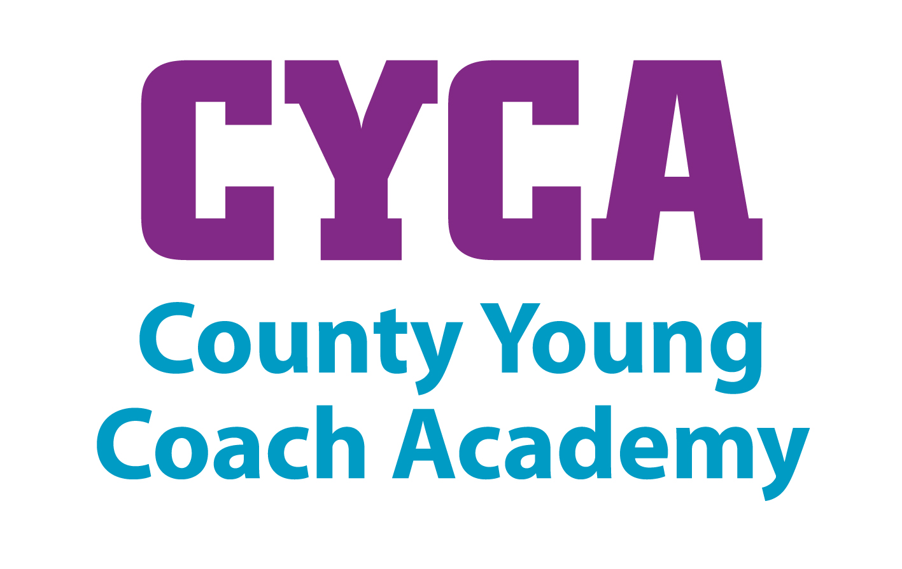

We are pleased to announce the launch of the application process for the 2015-16 County Young Coach Academy across Cambridgeshire and Peterborough and we would like to invite you to apply to be part of this Academy.

The aim of the County Young Coach Academy (CYCA) is to identify, support and develop our coaches of the future by offering a programme of training, personal development and mentoring support delivered by experienced coaches.

The CYCA is an exciting project that we are able to offer through our work as a lead partner for Leadership, Coaching and Volunteering, with the Youth Sport Trust. We are pleased to confirm that after two extremely successful years we will be further developing the CYCA programme this year and will continue to work with Living Sport, the County Sport Partnership for Cambridgeshire and Peterborough as a key delivery partner in this project.

The Academy will provide a pathway from school/ college leadership and volunteering programmes into coaching and possibly a career in sport by bridging the gap between school and community systems and signposting you to further opportunities.

The Academy is aimed at young people that want to develop as coaches, gain coaching qualifications or training and are committed to actively coaching within a school and/or community setting. Sessions will take place once every half term/ 6 times a year and will be held in the evening at a central venue. A wide range of topics will be covered and may include the following; training needs analysis, high quality coaching, FUNdamentals of movement, injury prevention, safe guarding, inclusive coaching and diet & nutrition.

Any young person aged 15+ who would be interested in joining should complete an application form and return it to Julie Pashley at the address above before the deadline of Friday 11th September. There will be a £30 joining fee for all successful applicants as a contribution towards the costs of a polo shirt and the annual CYCA programme of workshops.
If you require any further information, please do not hesitate to contact me.

Yours Sincerely

J Pashley

Julie Pashley
Project Officer
