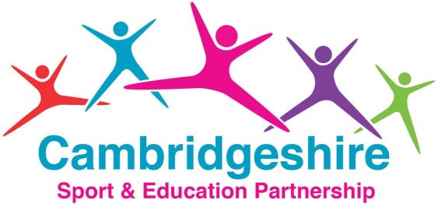TEAM BULDING RESOURCE & TRAINING
ORDER FORM

School Name: Tel:

Contact: Email:

Option | Description | Cost | Interested
Team Building Whole Staff Training  Receive whole school training to develop staff’s ability to facilitate learning in team building activities using the resource cards and pack.  Design a bespoke package to suit the needs of your school.  Utilise this approach for the benefit of whole school policy: eg.  - to promote Core Values  - to promote positive behaviour and reduce low level disruption  - to develop children’s social skills and ability to relate to others | Whole Day (6 hours)  An opportunity to explore the role of facilitator; increase knowledge, understanding and application of the Plan, Do, Review Model of learning through the practical use of the resource card activities.  Action plan together how best to apply team building principles for the benefit of your children. | £400
 | Half Day (3 hours)  Introduction to the role of facilitator; increase knowledge & understanding of the Plan, Do, Review Model of learning and experience example resource card activities. | £220
Class Team Building Events  Supporting Social, Moral and Cultural development in school. eg. Taking turns, fair play, praising and supporting others  Increase pupil’s self-esteem and confidence through Team Building activities, create a positive learning environment across the school | Full Day (5 hours)  Specialist deliverers will work with your pupils to develop their ability to work collaboratively, share space and provide positive critique, with an emphasis to create independent learners. | £375
 | Half Day (3 hours)  Specialist deliverers will work with your pupils to develop their ability to work collaboratively, share space and provide positive critique. | £250
Team Building Resource Pack/s | Order today at a special discounted rate | £49.95
Specialist Team Building Equipment  Complete specialist equipment sourced and purchased for you. eg.  - Charlotte’s Web  - Plank Walkers  - Blind Folds  - Giant Jenga | Our economy of scales will allow us to purchase these at a reduced rate for you | Total Circa £300  tbc
